Data Acquisition

* **Preparation:**
  + To include WiFi-data we need to **use Huawei phones**
    - I can provide you with one with the app already installed, **let me know when I can bring it to you**
      * today after 4:30
      * Tomorrow the whole day
  + Print out cheating sheet to know
    - how to use the app
    - how to access the data
    - which of the app label corresponds to which of our labels
  + **Train yourself first for >3 minutes** to get a better feeling of how to use the app
  + After your test run **go through each CSV file** if all data was actually recorded
  + Make sure the **phone is charged** and **WiFi and Bluetooth** are enabled (but keep flight mode on!)
* **Execution:**
  + **How to walk?**
    - **hold the phone** in a way you would if you would use a navigation app
    - always add some **buffer time** **before and after** labeling a transition
      * Already start recording >30 seconds before actually entering the building
      * keep walking at least 30 seconds inside a building before using another transition again
    - **Walk continuously**, meaning don’t stop recording and walk at least 1 hour
    - **Start and Finish outdoors** (this way it is probably easier to chain the time series together)
  + **How to label?**
    - label **2 steps before using a door**
  + **What to label?**
    - Label as much of the following combinations as possible and
    - at least 15 times for each combination

|  |  |  |  |
| --- | --- | --- | --- |
|  | **Outdoor > Indoor** | **Indoor** | **Indoor > Outdoor** |
| **Manual** | > 15 | > 15 | > 15 |
| **Automatic** | > 15 | > 15 | > 15 |
| **Automatic Button** | > 15 | > 15 | > 15 |

* **Other Remarks:**
  + **Take a photo of some doors** you used

**Cheating Sheet**

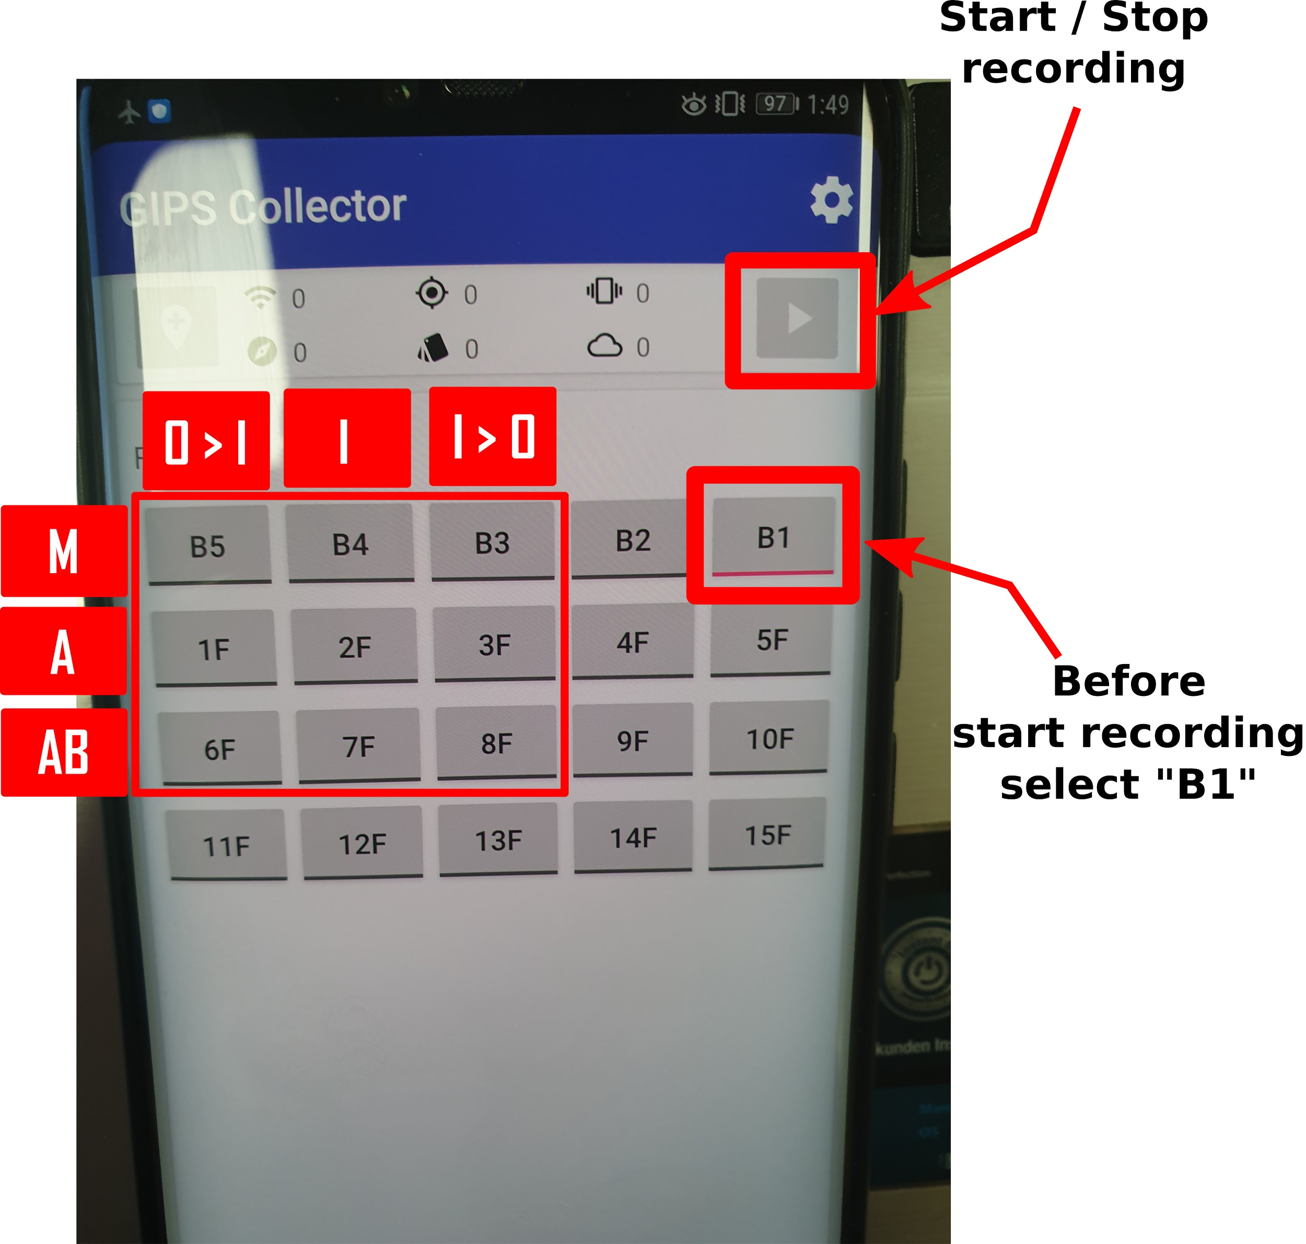

**Access recorded Data:**

**Files > Download > *latest folder***

(Transition.csv includes labels)

